AQAR 2023- 2024 PSGRKCW



Media Centre Details
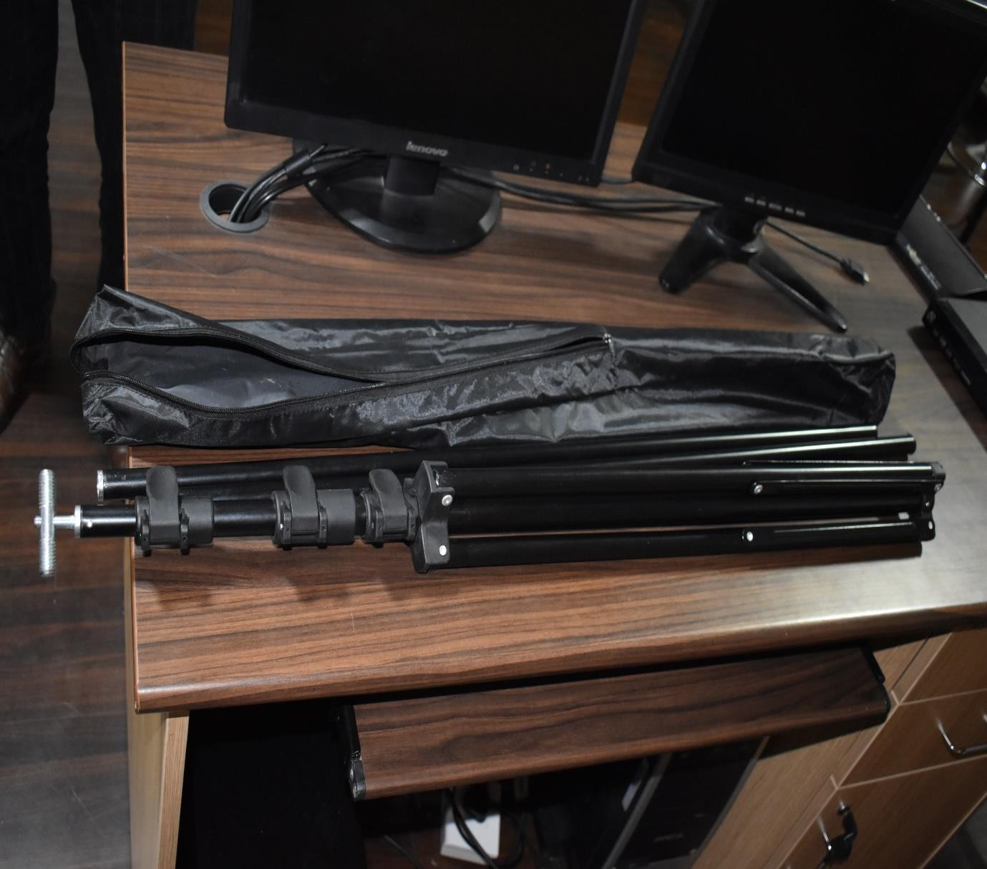
T Shape Stand

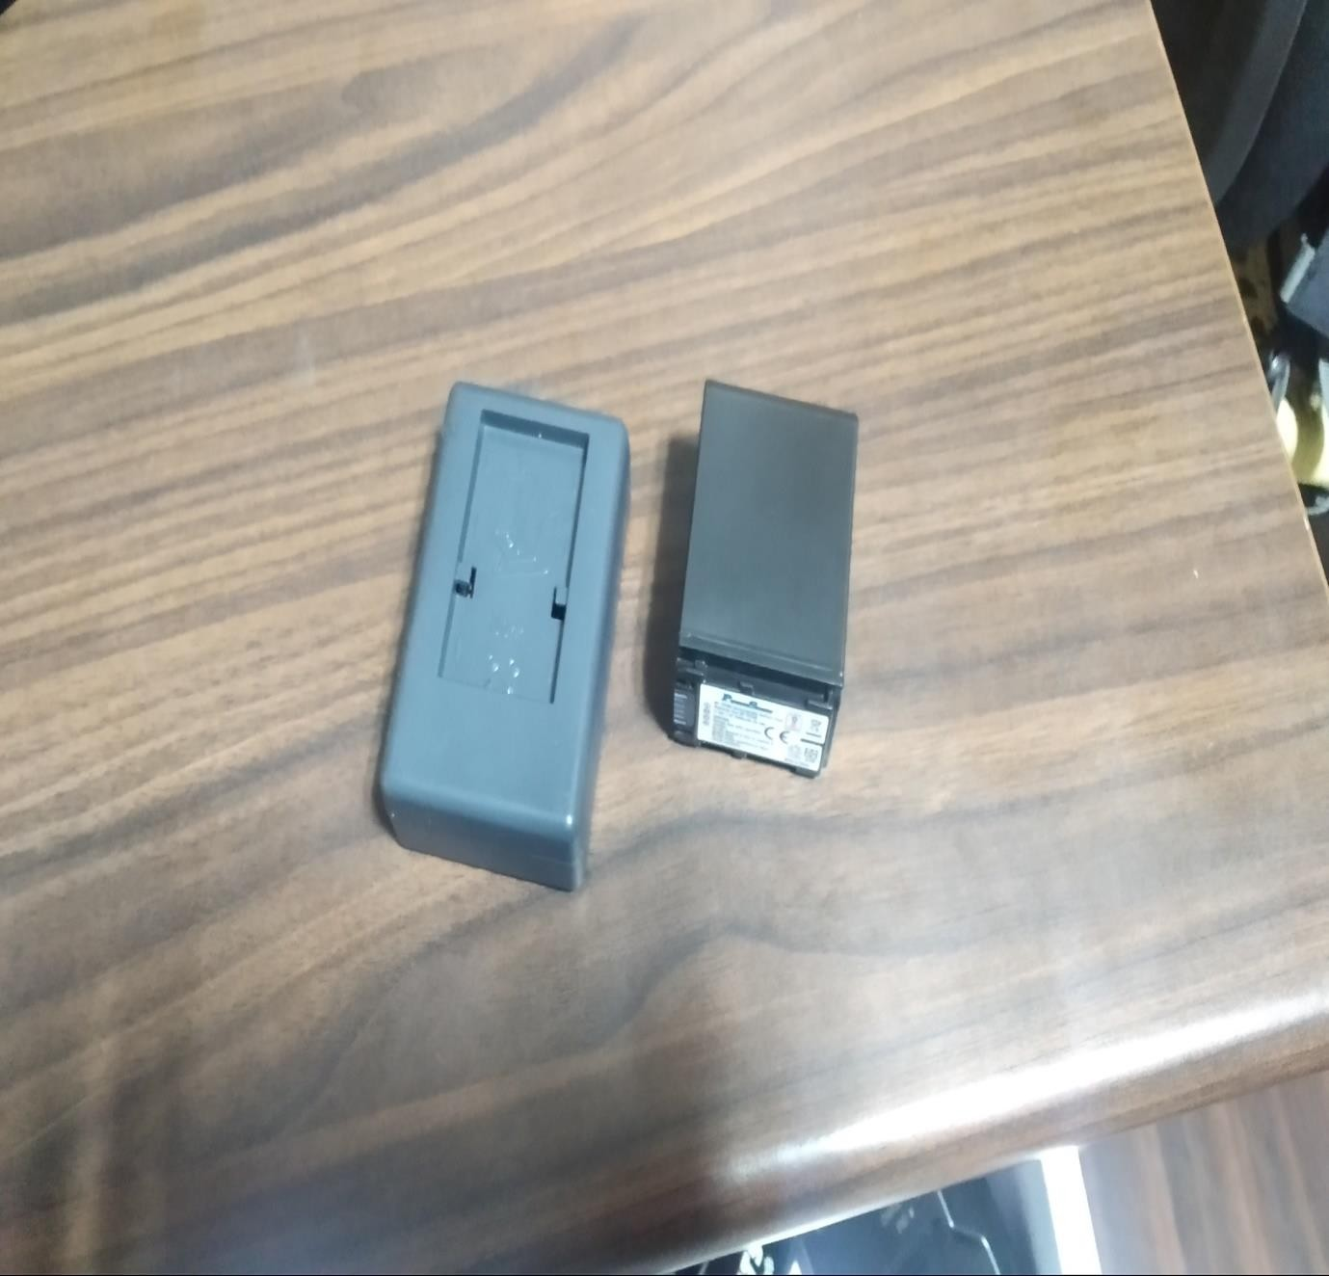
Power smart charger & Battery

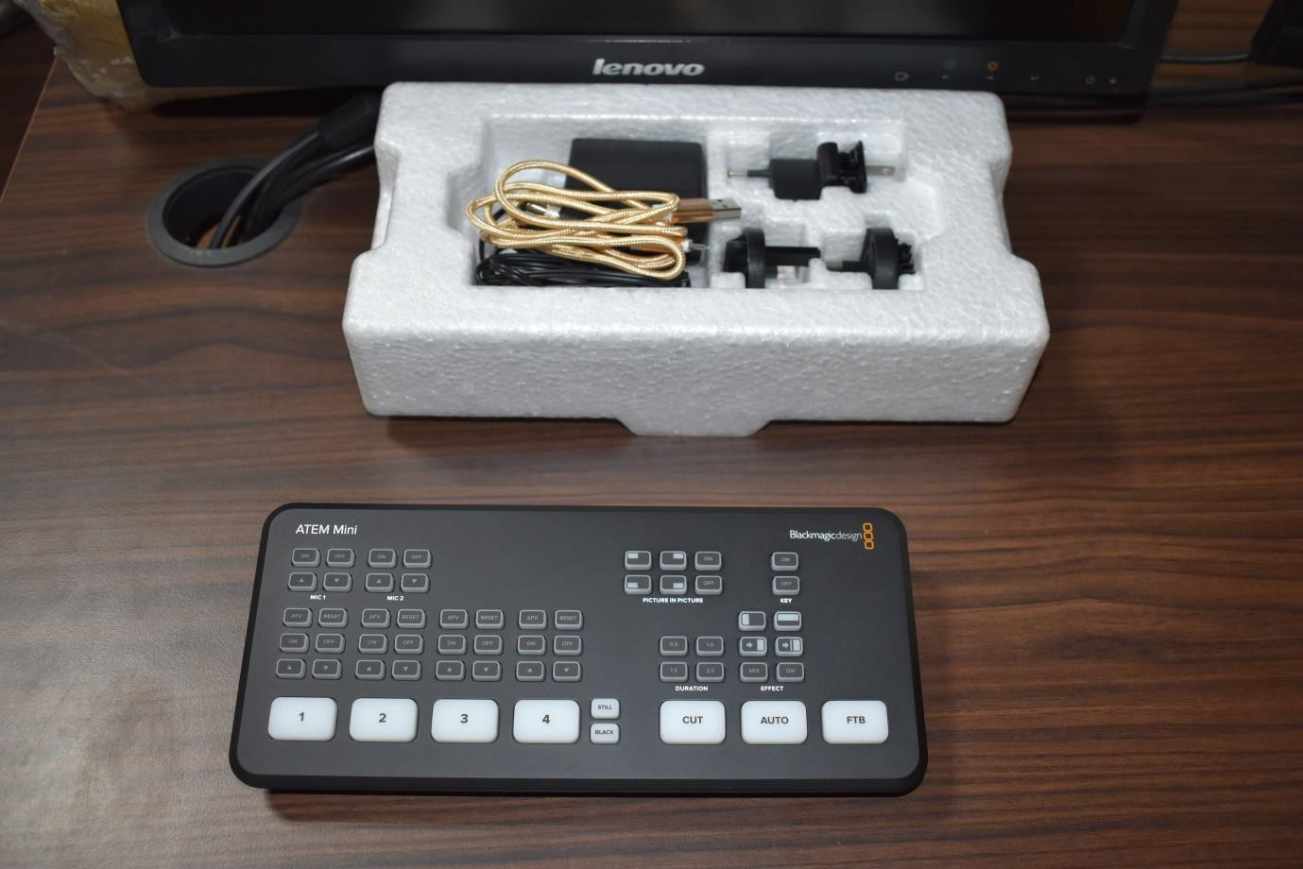
Atem mini Capture

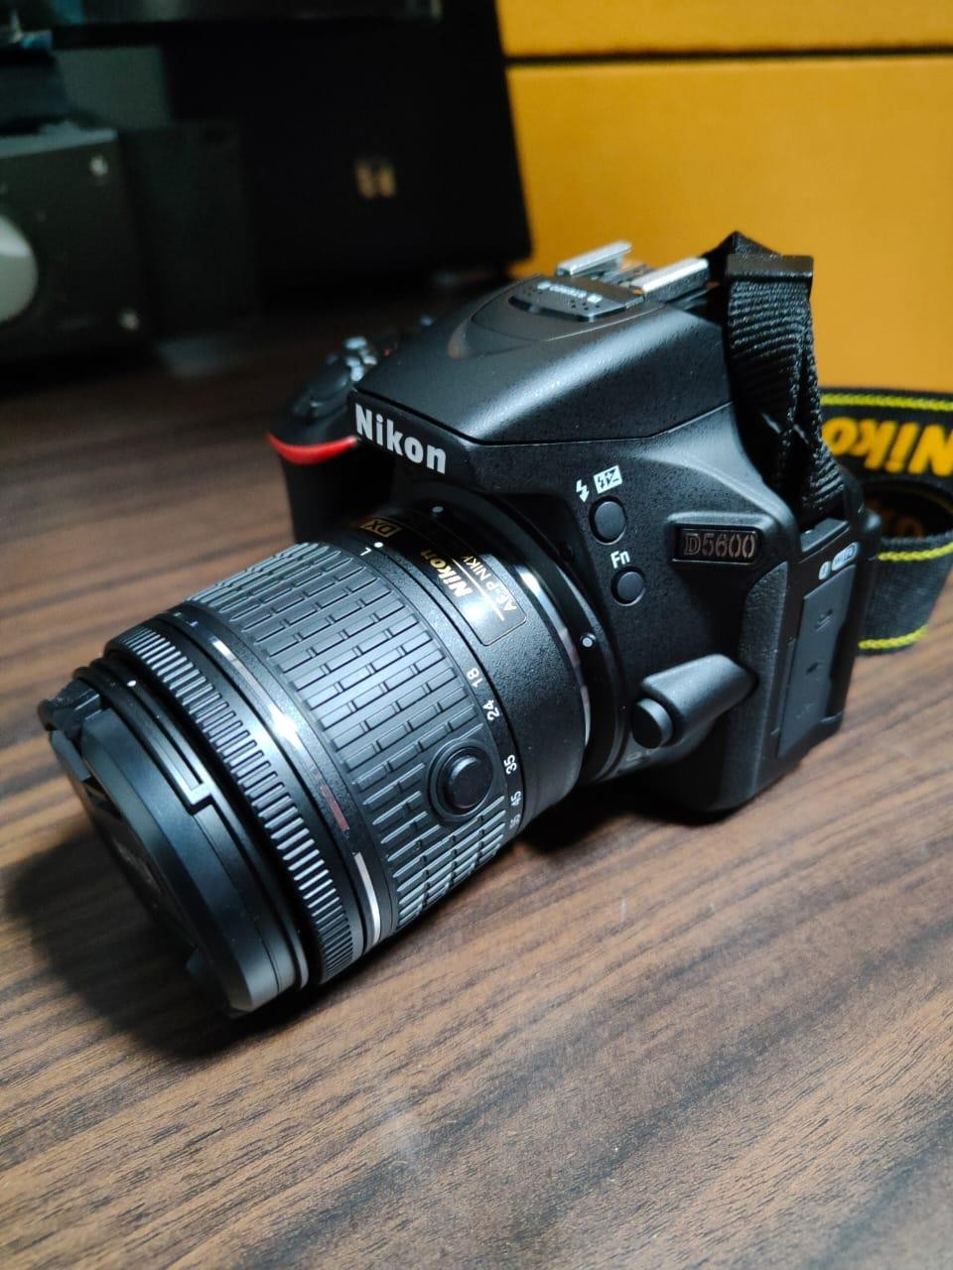

Nikon D 5600 Camera

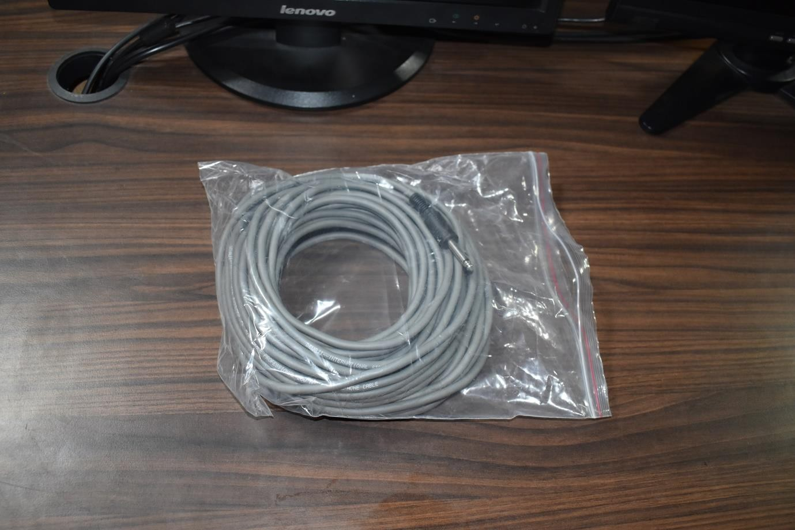

Mono pin Cable

